Great Empire

Generals send messages to their Army about their future plans on 5/12. Help the decoder to decrypt the message that is Oujp{FnFjwcYnjln}.

**Category** : Cryptography

**Difficulty** : Low Level

Solution

5/12 - This Means Caesar Cipher has 5 and 12 as Key

Step 1 : With Key 12

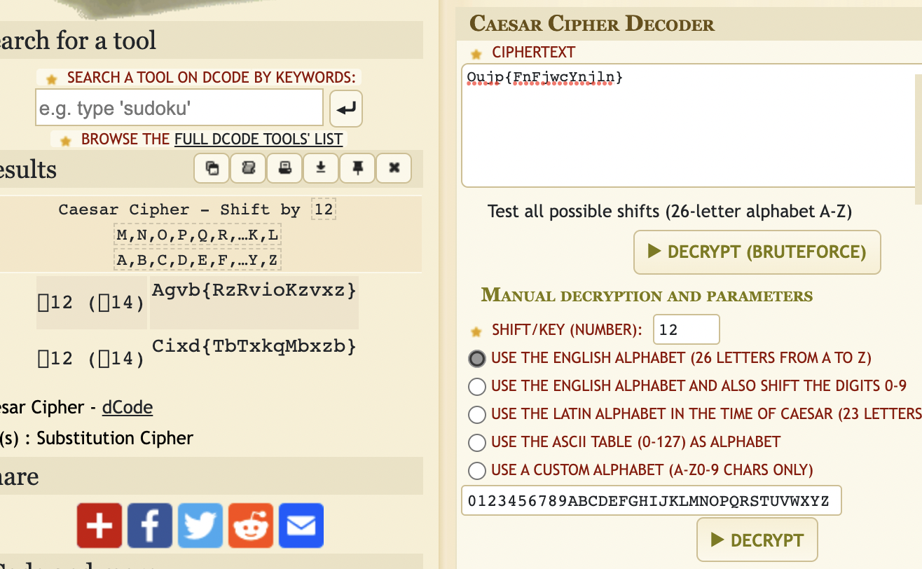

We will found a cipher text : Agvb{RzRvioKzvxz}

Step 2: With Key 5

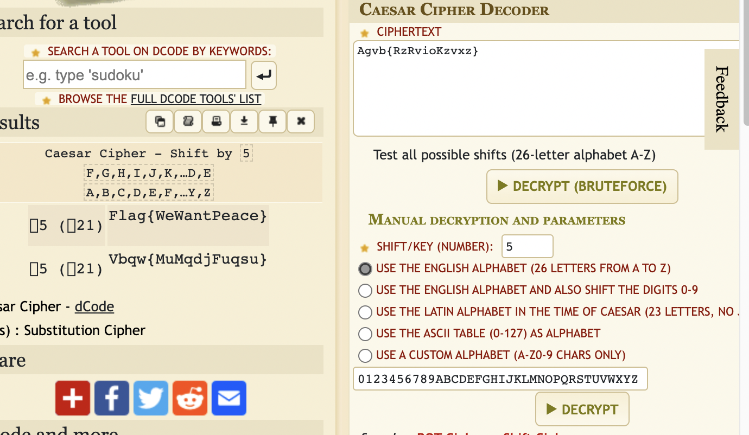

Answer

Flag : Flag{WeWantPeace}